Varinder Singh
Male
Email: varinder04@gmail.com
M: +91-9619484452

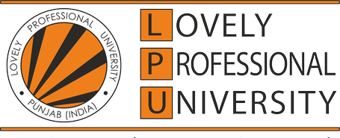

ACADEMIC QUALIFICATIONS

Year | Degree | Institute | CGPA / Percentage
2020 | B.Tech(Mechanical Engineering) | Lovely Professional University, Phagwara | 8.8/10
2013 | I(ICSE) | DAV Public School, Jamshedpur | 92.8 %
2011 | X(ICSE) | DAV Public School, Jamshedpur | 92.4%

PROJECTS
Tata Motors, Jamshedpur Jun 2016- July 2016
- PPAP for G-1150 Gearbox: The project was to develop Project Part Approval Process (PPAP) for the upcoming gear box of newly launched World Truck. The list of all the components used in the gear box was compiled and management approval was take through the New Product Implementation Team. Also, the entire assembly of a Gear Box was studied.

POSITIONS OF RESPONSIBILITY
- President at Rotaract Club 2015-2016
- Student Coordinator, Literary Society – Lovely Professional University 2015-2016
- President, Automobile Club – Lovely Professional University 2016-2017

EXTRA CURRICULAR ACHIEVEMENTS
Community Service | - Member of NSS for 3 years  - Organized Blood Donation Camps under the aegis of National Service Scheme  - Organized Tree Plantation Campaign at Lovely Professional University
Achievements | - Awarded 1st Prize in Chakravyuh – Personality Hunt Competition in the Annual Tech Fest of Lovely Professional University  - Awarded 1st Prize in B-Plan Competition organized by Lovely Professional University  - Awarded 2nd Prize in Effi-cycle, Cycle Making Competition organized by Lovely Professional University

LANGUAGE PROFICIENCY
- English
- Hindi
- Punjabi
- Odiya
PERSONAL DETAILS
- Date of Birth : 20th March 1994
- Nationality : Indian
- Address : H. No 21, Hume Pipe Area, Sakchi, Jamshedpur – 831001, Jharkhand

